CprE 381 – Computer Organization and

Assembly-Level Programming

Lab-01 Report

Student Name Ben Pierre______________________________________

Section / Lab Time 10/5:10pm____________________

Submit a typeset pdf version of this on Canvas by the due date (i.e., the start of your next lab section). Refer to the highlighted language in the Lab-01 instructions for the context of the following questions.

- [Part 1 (b)] Reference the circuit diagram at the end of this document (some parts simplified). There are 33 labeled areas in the diagram. For each of these labels, specify where (VHDL file and line number) these values are located – some will be found in more than one place. Also attempt to explain the functionality of each label as it occurs in the code.

- 1 is cA, the input(iA) to the multiplier g-Mult1, which provides a number to be multiplied. Defined and set on Line 49 Quadratic.vhd
- 2 is IX, an input to both g_Mult1(iB) and to g_Mult2(iB), which provides the second number to multiply by. Defined on Line 25 Quadratic.vhd
- 3 is cB, which provides input iA to g_multi2, providing one of the numbers to be multiplied. . Defined and set on Line 50 Quadratic.vhd
- 4 is cC, or input iB to g_add1, which is the number to be added to a previous number. . Defined and set on Line51 Quadratic.vhd
- 5 is the iCLK, which provides the clock input for the while circuit. This is mentioned in lines 28 of Adder.vhd and 28 of Multiplier.vhd, but overly defined on line 35 of Quadratic.vhd
- 10 is the Output of g_Mult1, the value being held in the latch of g_Mult1.Defined on line 31 pf multiplier.vhd, set on line 41. This is used on used on line 70 of Quadratic.vhd as sValue_Ax
- 14 is the Output of g_Mult2, the value being held in the latch of g_Mult2. Defined on line 31 pf multiplier.vhd, set on line 41. This is used on used on line 76 of Quadratic.vhd as sValue_Bx
- 23 is the Output of g_Mult3, the value being held in the latch of g_Mult3. Defined on line 31 pf multiplier.vhd, set on line 41. This is used on used on line 85 of Quadratic.vhd as sValue_Cx
- 9 is the Latch the stores the output of g_Multi1,it updates when iClk is high. This is connected to (10)oc. This is shown in the block of code from lines 40 to 42 in Multiplier.vhd
- 19 is the latch that stores the output of G_Add1, and updates when iCLK is high.This is connected to 20(oc). This is represented in lines 40-42 of Adder.vhd
- 29 is the output value of the who Quadratic, oY. This is defined on line 26 of Quadratic.vhd and set on line 100
- 8 is the multiplier logic for g_Multi1. It takes inputs iA and Ib and multiplies them, passing them to (9) to output on the next cycle. This is represented in line 41 of Multiplier.vhd
- 18 is the adder logic for g_Add1, it adds inputs Ia and Ib together before passing them to 19 to output later. This is represented on line 41 of Adder.vhd
- 11 is g_Mult1, it takes inputs cA and Ix, multiplies them and passes them to sValue_Ax on the high edge of iCLk. This is defined and used on lines 66 through 70 of quadratic.vhd
- 28 is g_Add2, which takes inputs iA and iB and adds them, passing them to Oc on the high edge of iCLK. This adder is declared on line 96 and set on lines 97 through 100 of Quadratic.vhd

- [Part 1 (h)] In your report, provide a brief explanation of how the timing waveform corresponds to your understanding of the adder design.
  - The values did not update right away but instead updated on the high edge of ICLK, showing that the output value was only passed on rising edges.
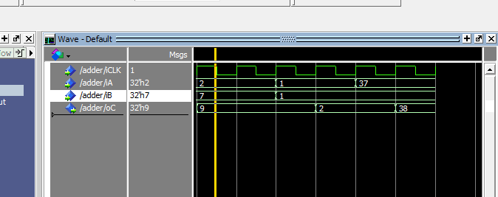
- [Feedback] You must complete this section for your lab to be graded. Write down the first response you think of; I expect it to take roughly 5 minutes (do not take more than 10 minutes).

  - How many hours did you spend on this lab?

Task | During lab time | Outside of lab time
Reading lab | .5 | 0
Pencil/paper design | 0 | 0
VHDL design | .5 | 0
Assembly coding | 0 | 0
Simulation | .5 | 0
Debugging | 0 | 0
Report writing | .5 | 0
Other: | 0 | 0
Total | 2 | 0

  - If you could change one thing about the lab experience, what would it be? Why?
Instructions that agree with each other

  - What was the most interesting part of the lab?
I was surprised at how easy it was to adapt my prior knowledge to write this code, and enjoyed the oscilloscope like waveforms

